**Unit Testing of SHAW OM PointOfSales From Cloud to LogFire**

**Step:1**

**Query to get the Serial numbers which are in issued out of stores status of a particular org in ERP:**

SELECT

iop.organization_code,

sib.item_number,

isn.current_subinventory_code,

fl.meaning serial_status,

isn.serial_number,

isn.lpn_id,

isn.last_update_date,

isn.last_updated_by,

isn.creation_date,

isn.created_by

FROM

inv_serial_numbers isn,

inv_org_parameters iop,

egp_system_items_b sib,

fnd_lookups fl

WHERE

fl.lookup_type = 'INV_SERIAL_NUM_STATUS'

AND isn.current_status = fl.lookup_code

AND isn.current_organization_id = iop.organization_id

AND isn.current_organization_id = sib.organization_id

AND isn.inventory_item_id = sib.inventory_item_id

AND isn.last_update_date =

(

SELECT

Max(last_update_date)

FROM

inv_serial_numbers

WHERE

serial_number = isn.serial_number

)

AND iop.organization_code = 'CGY'

AND fl.meaning LIKE 'Issued out%'

ORDER BY

isn.serial_number;

* Select some transactions from the above query and receive it manually through ERP application

**Step 2:** To receive the serials in ERP follow the Navigation

* **Supply Chain Execution>Inventory Management>Create Miscellaneous Transaction**

**Enter Organization**

**Transaction_Type**: Shaw Project Receipt

**Account**: 200.0000.15010.051999.0000.00000.000000.000

* Enter Item Number, Sub inventory, Quantity
* Click the Records lots and serial numbers tab and enter the serial numbers in **enter single serial number** tab

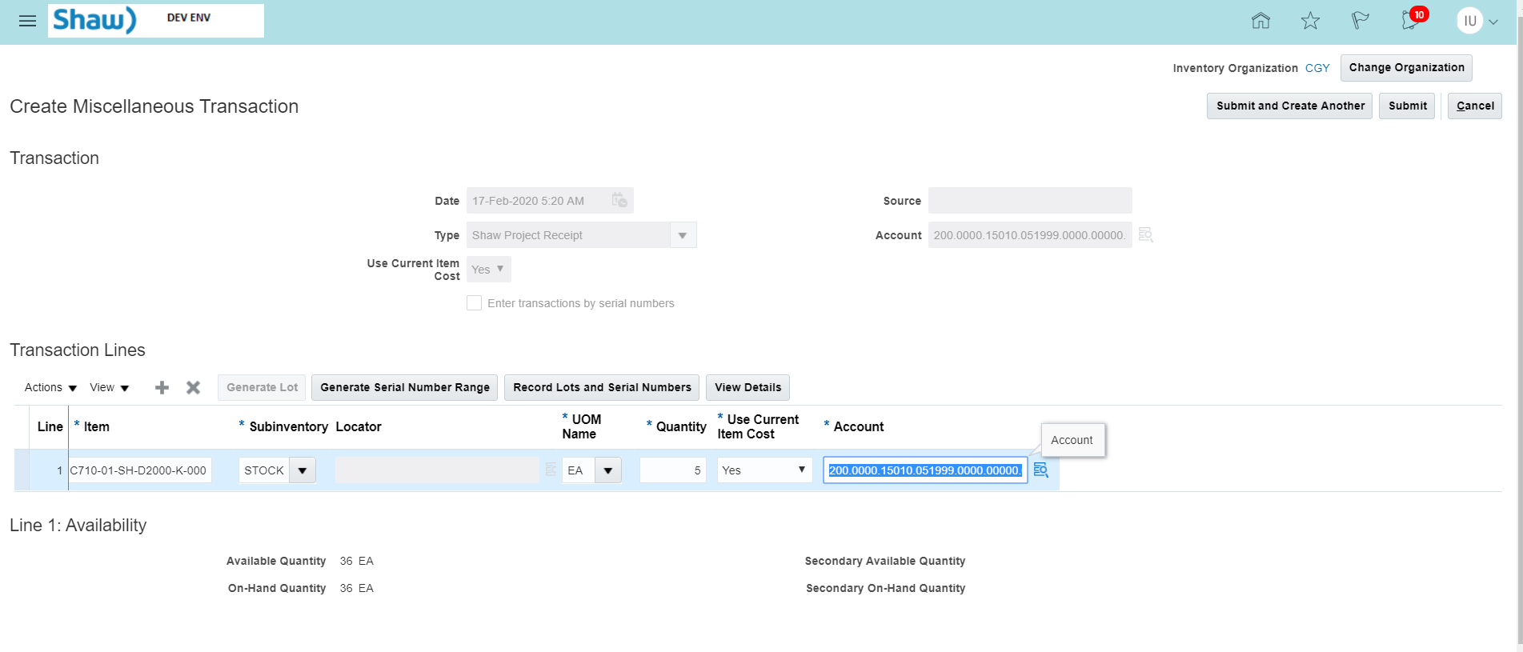

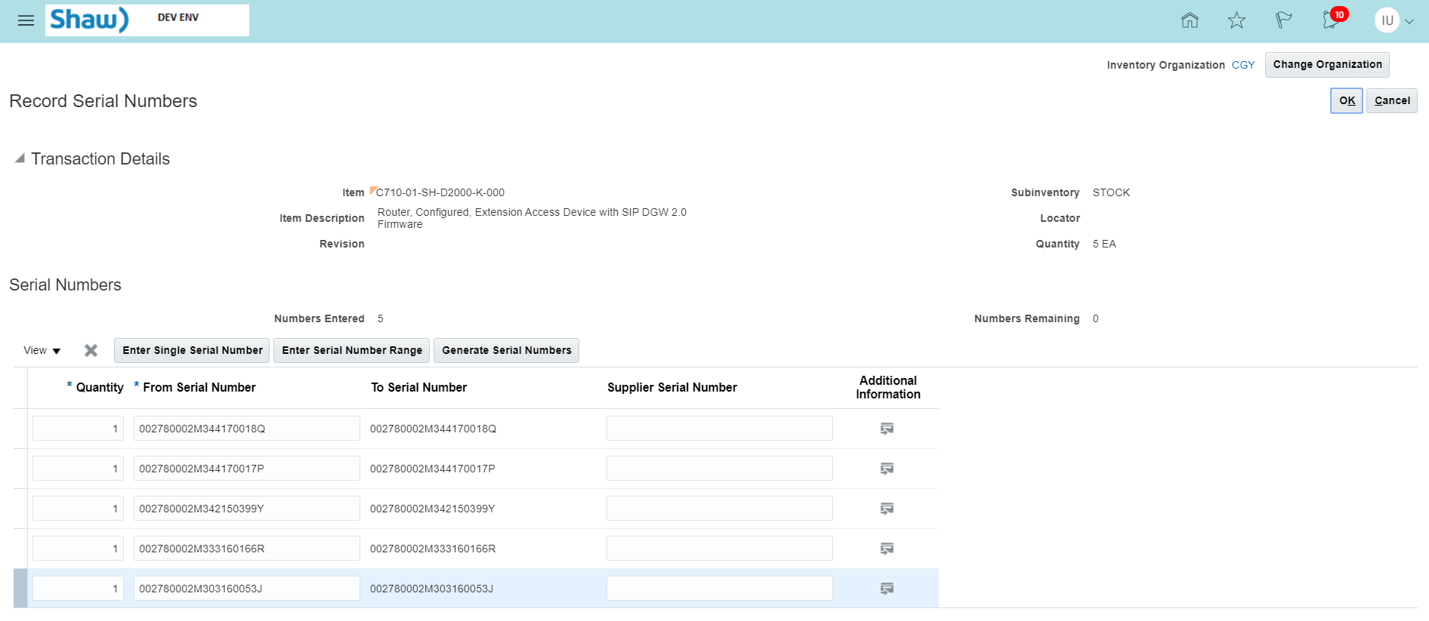



Click Ok button

Click View Details





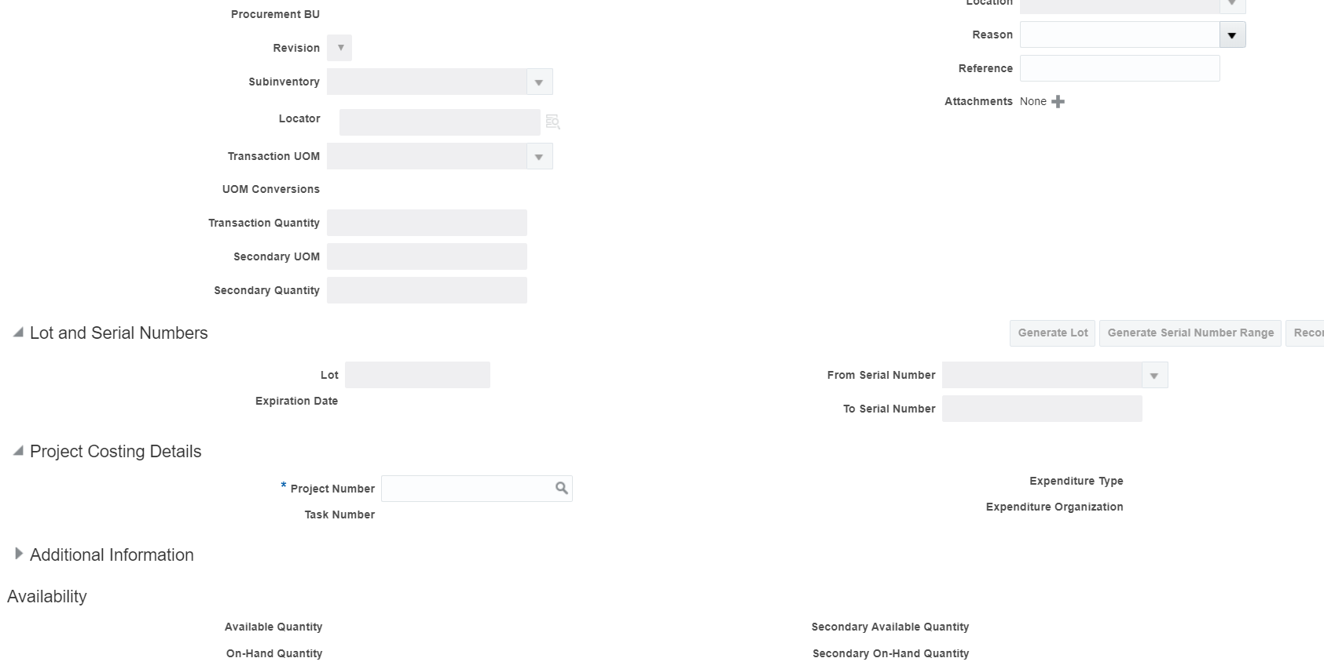

To get the **Active Project Number and Task Number** run the below query in cloud ERP

select

'''' || a.segment1 || '|' || b.task_number || ''',',

a.project_status_code,

a.segment1,

b.task_number,

b.CHARGEABLE_FLAG,

case

when

b.completion_date > sysdate

then

'Active'

else

'Inactive'

end

Task_Status

from

pjf_projects_all_vl a, pjf_tasks_v b

where

a.project_id = b.project_id

and a.project_status_code = 'ACTIVE'

and b.CHARGEABLE_FLAG = 'Y'

and b.completion_date > sysdate;

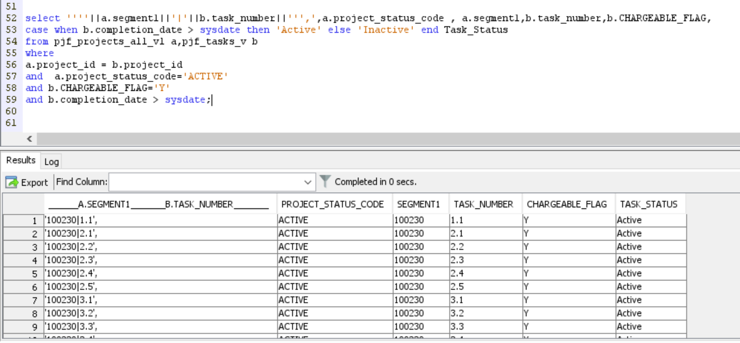

**Enter Active Project Number ,Task Number ,Expenditure Organization : Accounting**

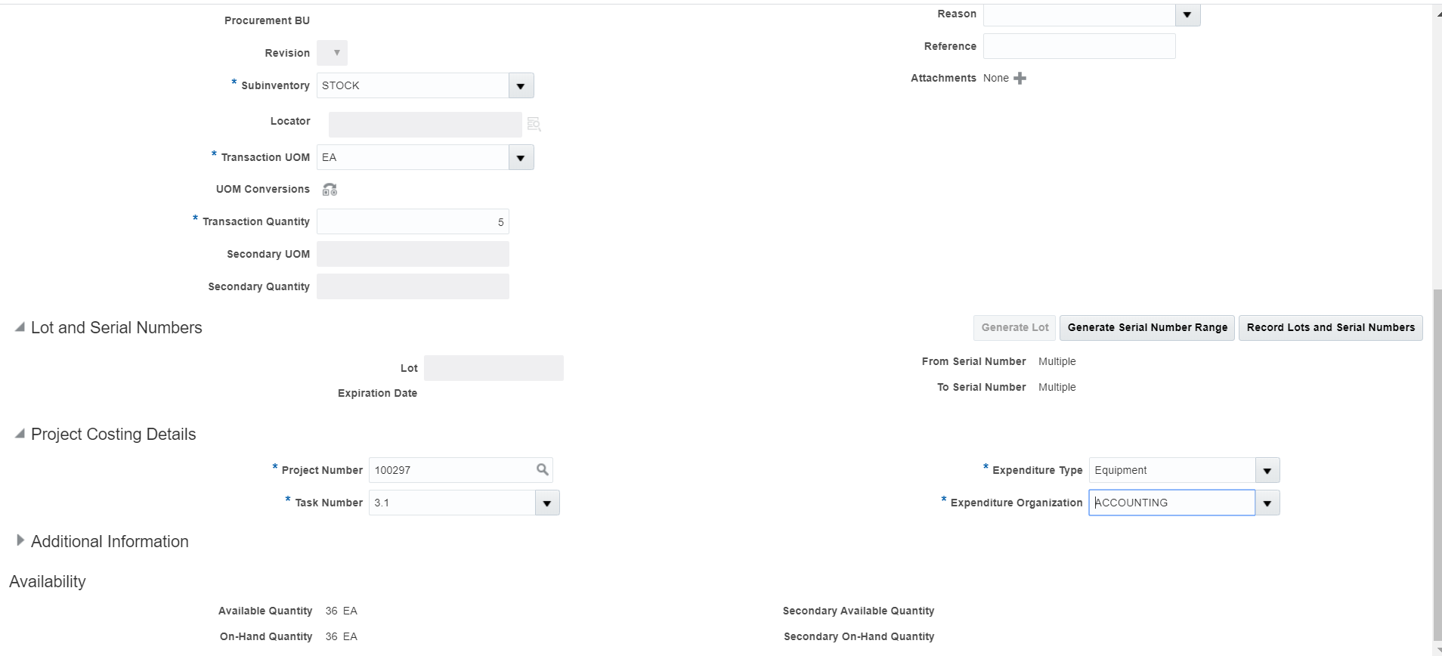

**CLICK OK BUTTON**

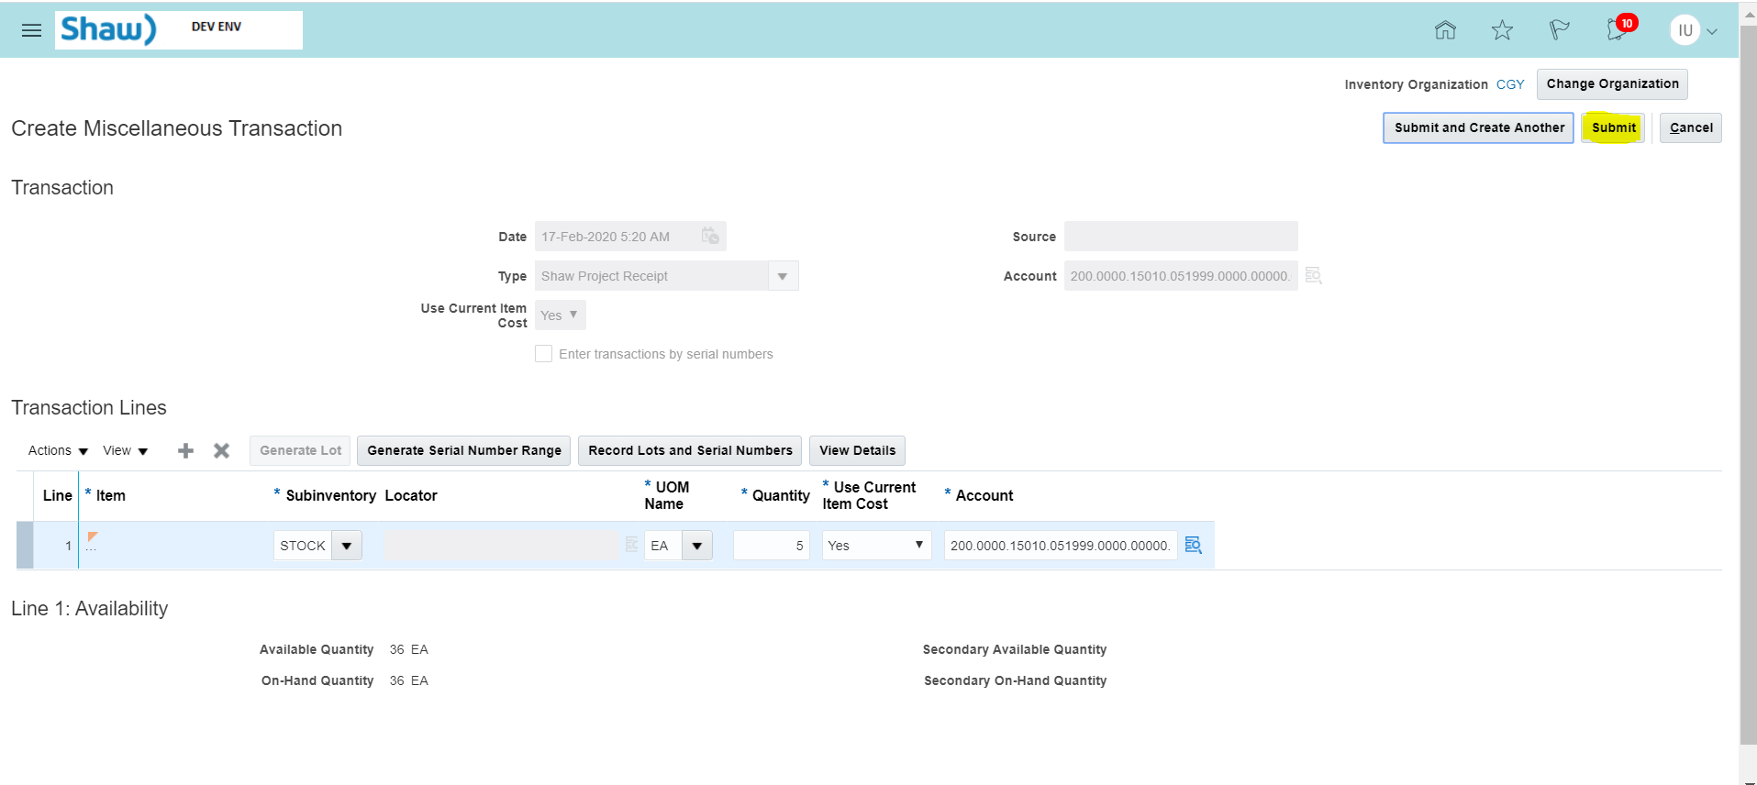

**Click Submit button**

**Check the Status of serial numbers in ERP**

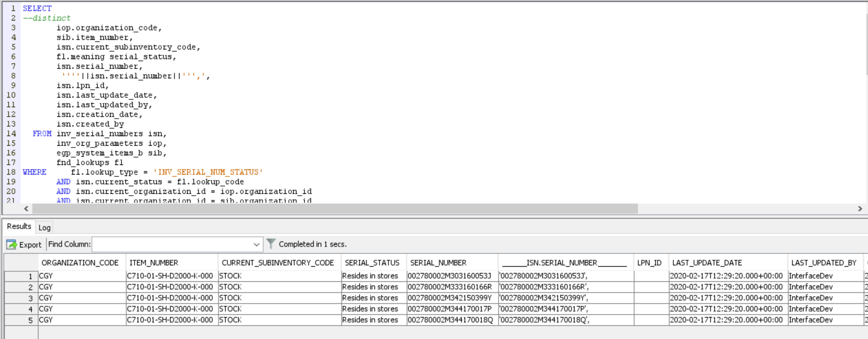

Now , the serial numbers are received in ERP

Run the integration “SHAW OM PointOfSales From Cloud to LogFire”

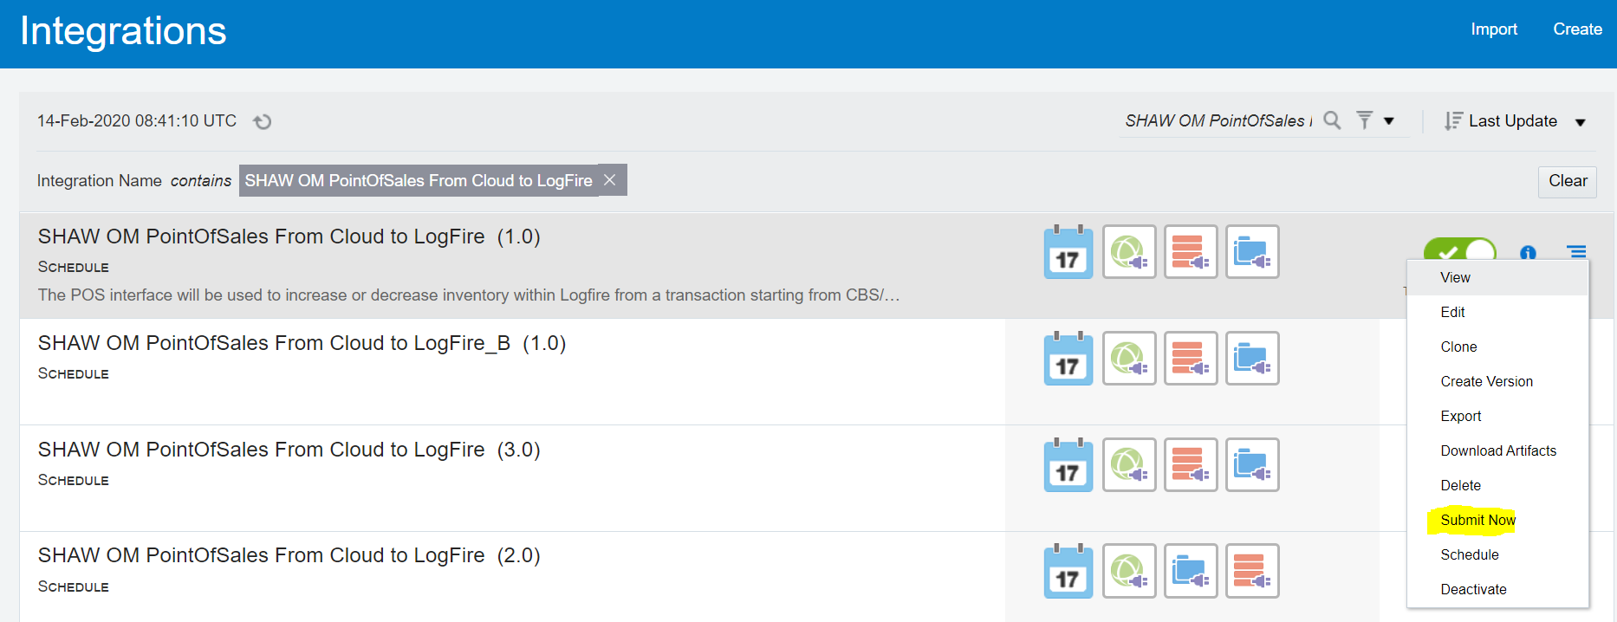

Run the below query to get Current_Run_Date and Last_Successful_Run

SELECT *

FROM SHAW_INTERFACE_RUN_DETAILS

WHERE rice_id = 'LOG-INT-18';

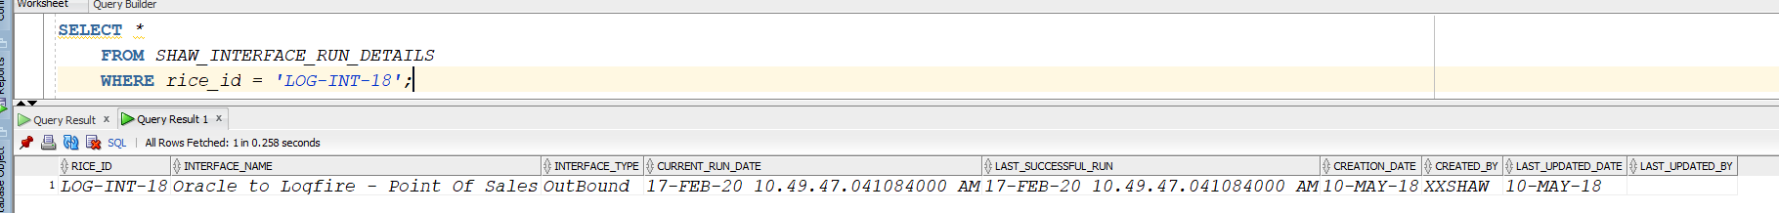

SELECT a.status,a.* FROM SHAW_OM_POS_LOGFIRE_STG a WHERE serial_nbr in ('002780002M303160053J',

'002780002M333160166R',

'002780002M342150399Y',

'002780002M344170017P',

'002780002M344170018Q');

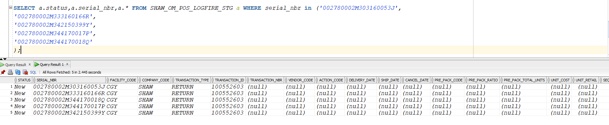

The records got inserted in SHAW_OM_POS_LOGFIRE_STG

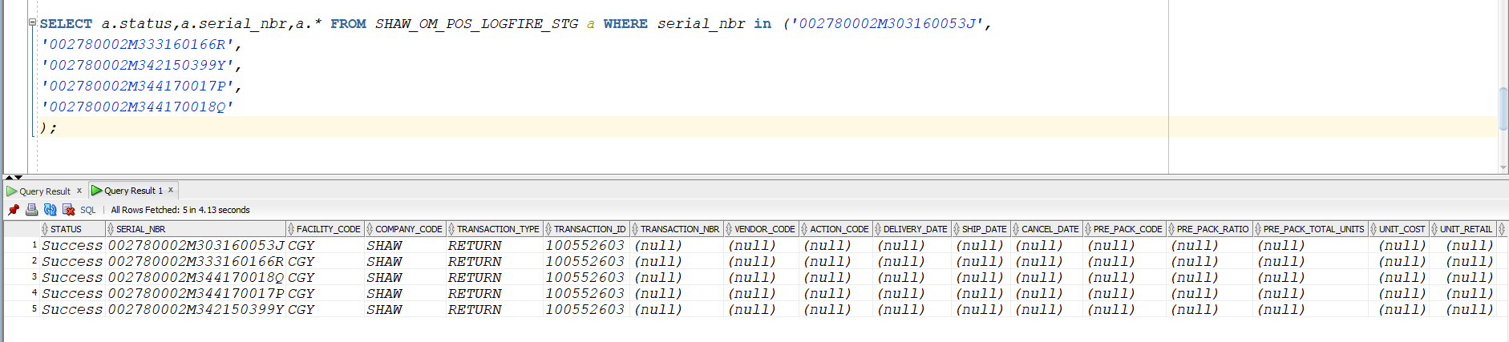The Records got Processed

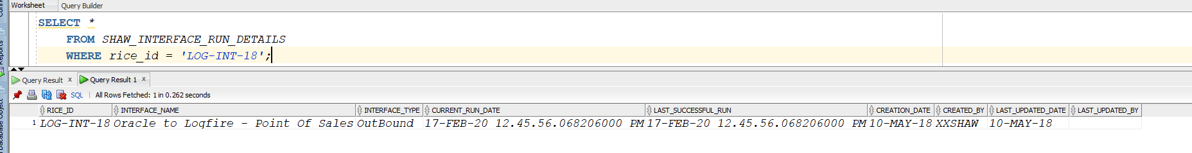

Current_Run_Date and Last_Successful_Run has been updated.

File is created in Out and Archive folder in FTP Server

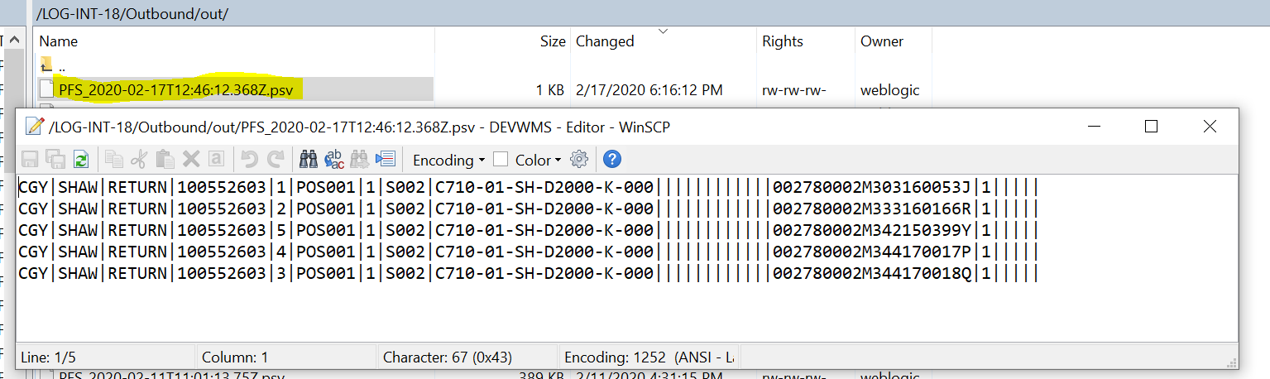

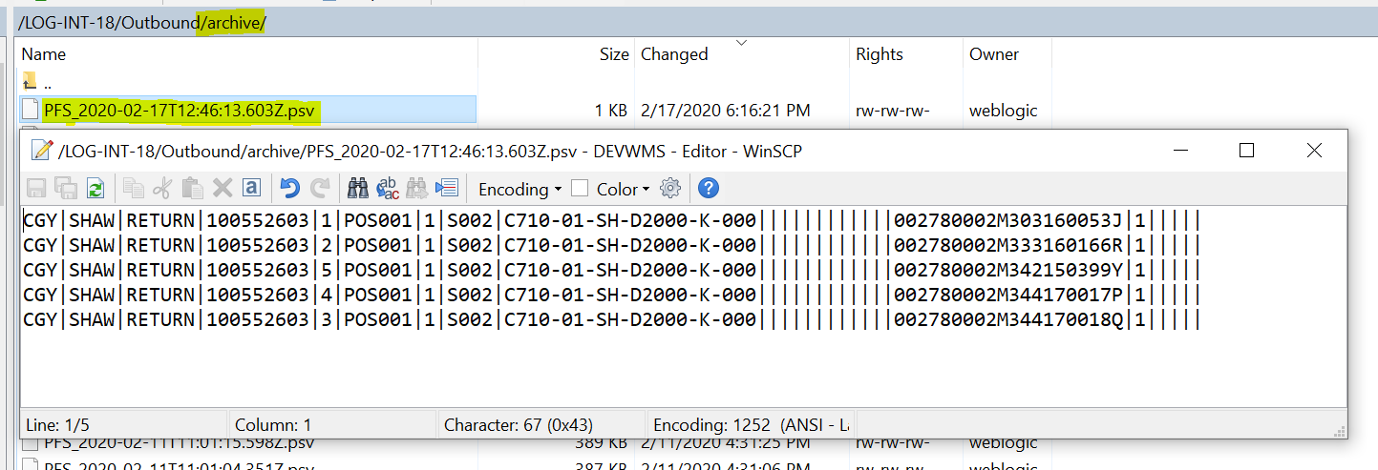

Tracking in ICS

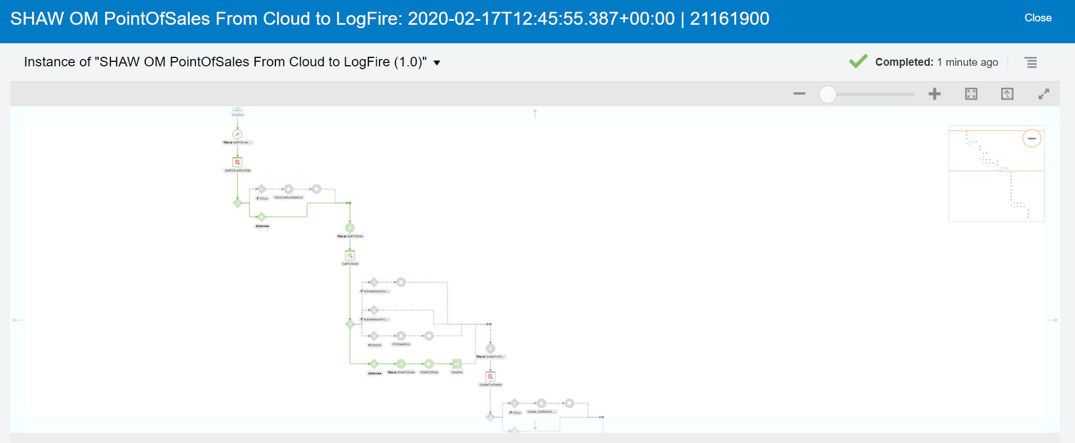

**4 TEST CASES FOR LAST SUCCESSFUL RUN DATE**

|  |  |  |  |
| --- | --- | --- | --- |
| **Case** | **Systimestamp** | **Current_Run_Date** | **Last_successful_run_date** |
| **New/Reprocessed** | **5thMarch 10am** | **5thMarch 10am** | **5thMarch 10am** |
| **New** | **5th March 10.30am** | **5th March 10.30am** | **5th March 10.30am** |
| **Reprocessed** | **5th March 11am** | **5th March 11am** | **5th March 10.30am** |
| **New** | **5th March  11.30am** | **5th March  11.30am** | **5th March  11.30am** |

**1ST Scenario**

One record reprocessed to ‘New’ from staging.

2 records will be inserted from last successful run date to current rundate.

**LAST_SUCCESSFUL_RUN_DATE**

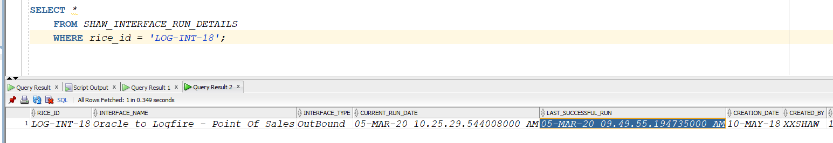

**CURRENT_RUN_DATE**

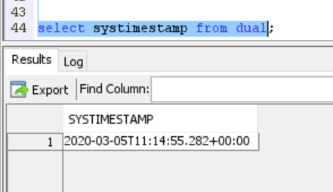

**DATA WHICH WILL BE FETCHED FROM ERP QUERY THROUGH WEB SERVICE CALL IN ICS**

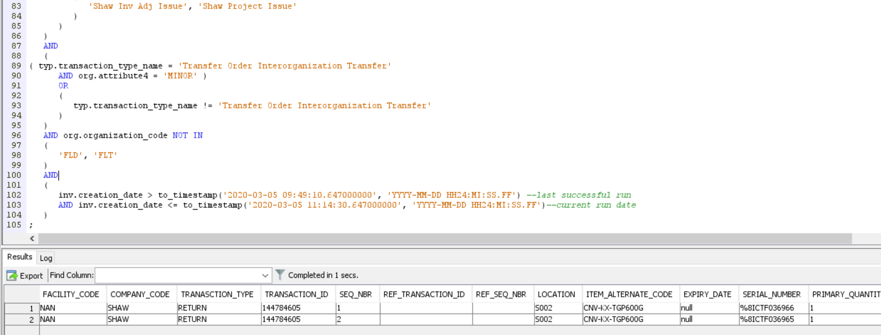

**REPROCESSED RECORD**

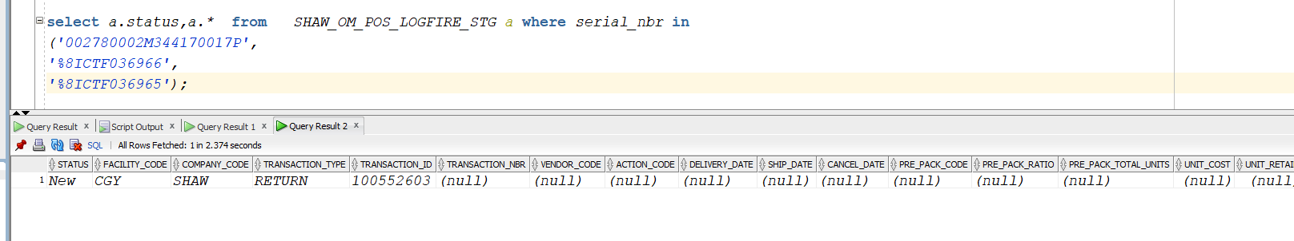

**SUBMIT INTEGRATION**

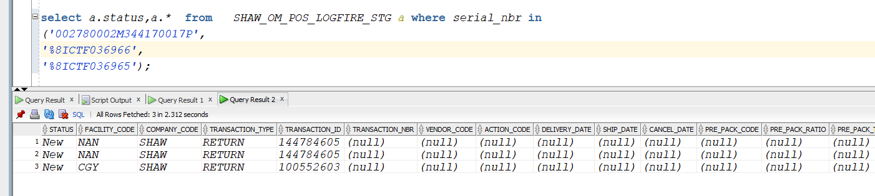

**RECORDS GOT PROCESSED**

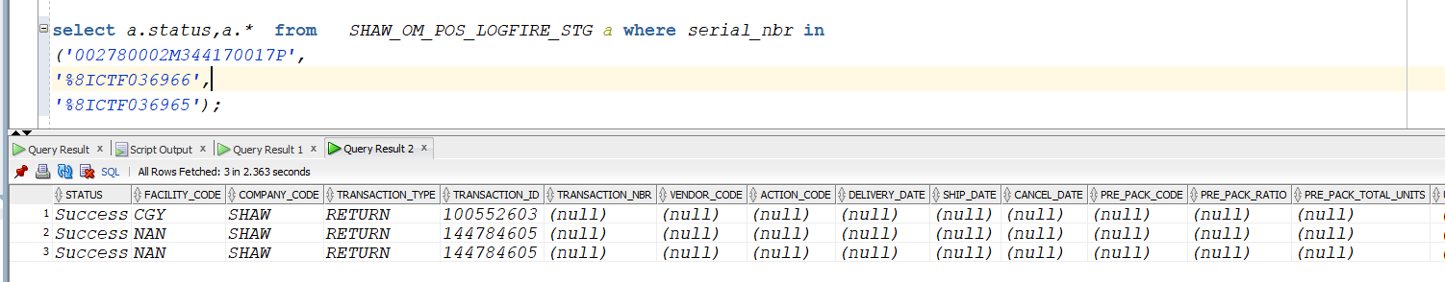

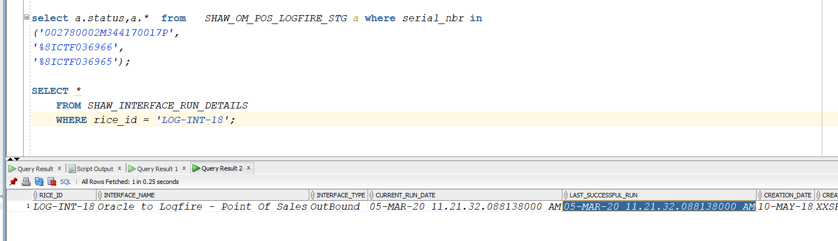

TRACKING IN ICS

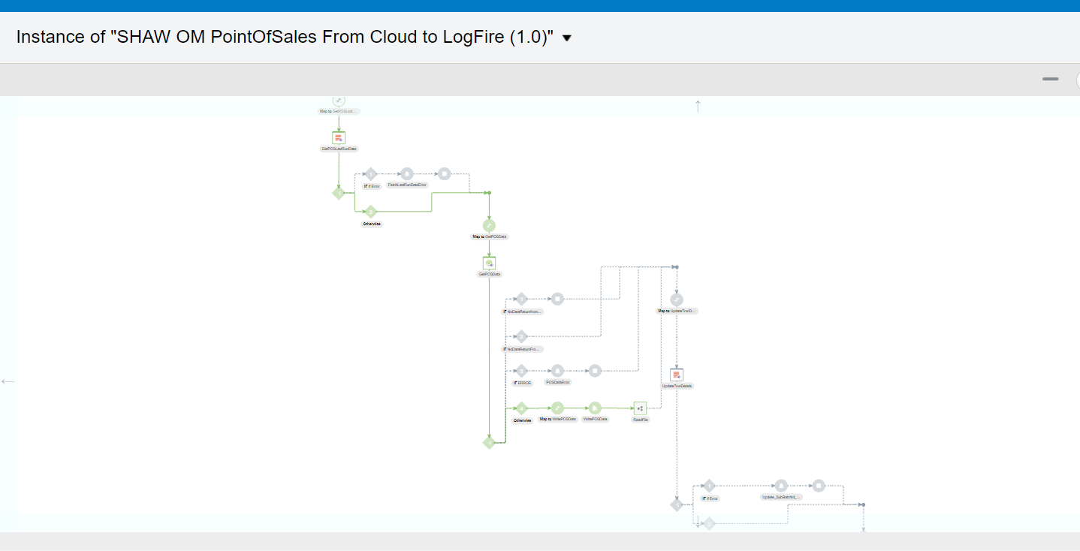

**2nd Scenario**

Two records will be inserted from last successful run date to current run date

**LAST_SUCCESSFUL_RUN_DATE**



**CURRENT_RUN_DATE**

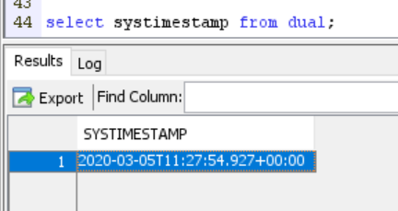

**DATA WHICH WILL BE FETCHED FROM ERP QUERY THROUGH WEB SERVICE CALL IN ICS**

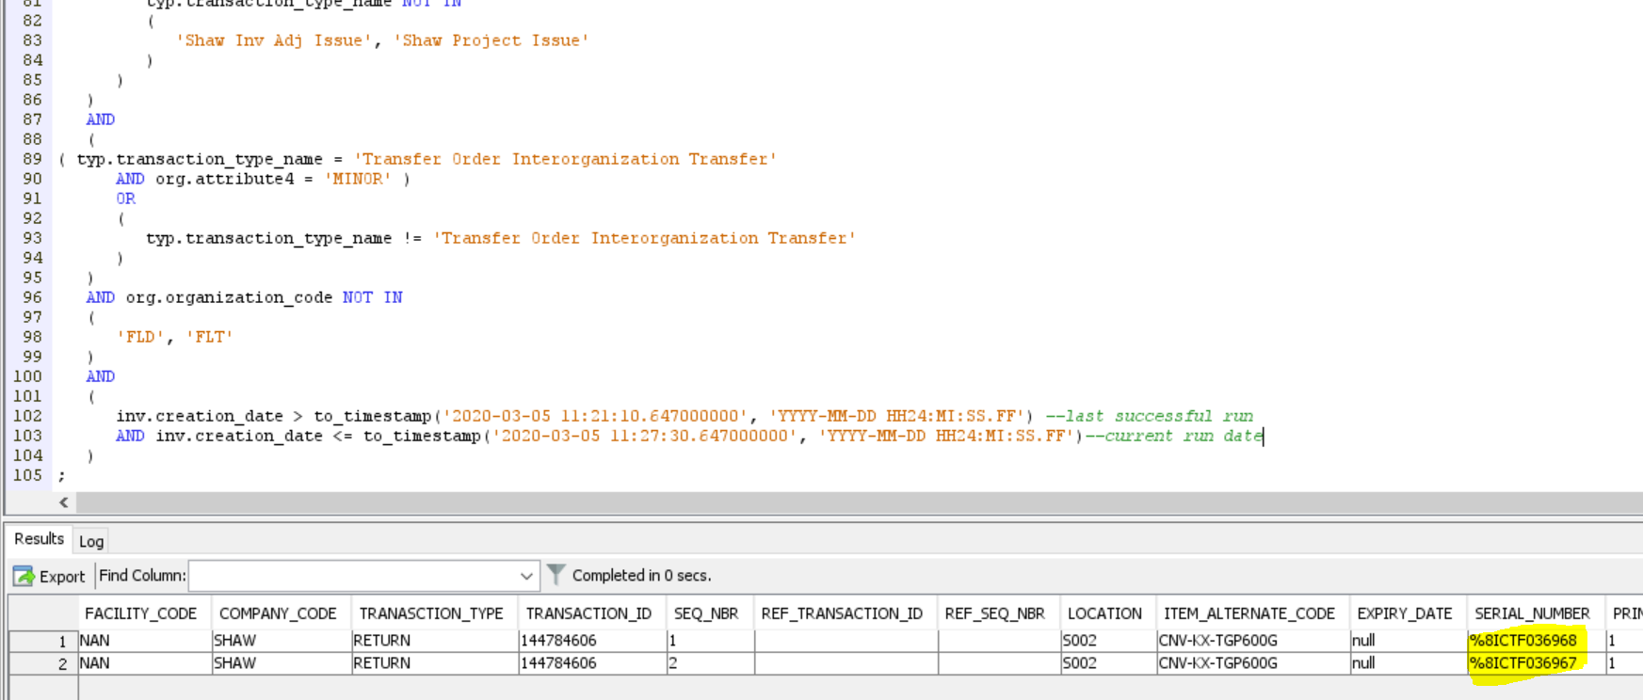

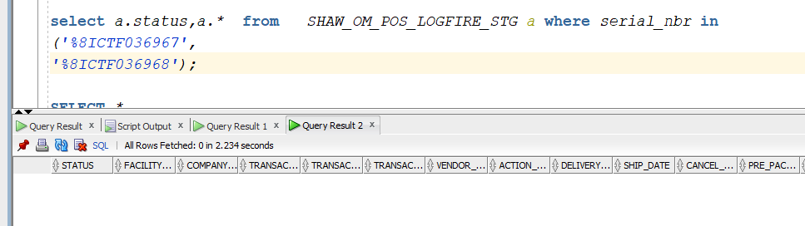

**SUBMIT INTEGRATION**

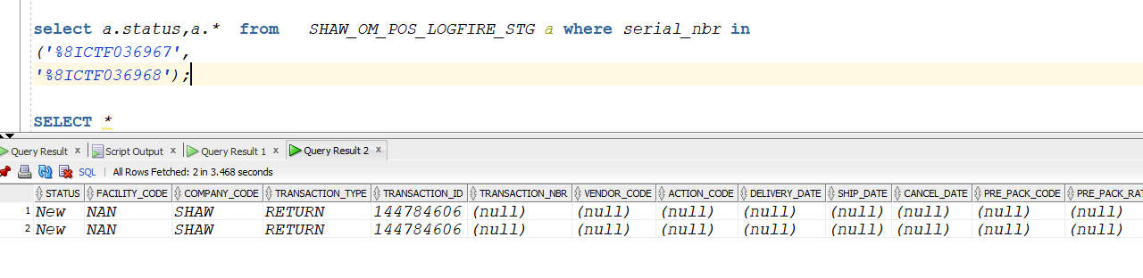

**RECORDS GOT PROCESSED**

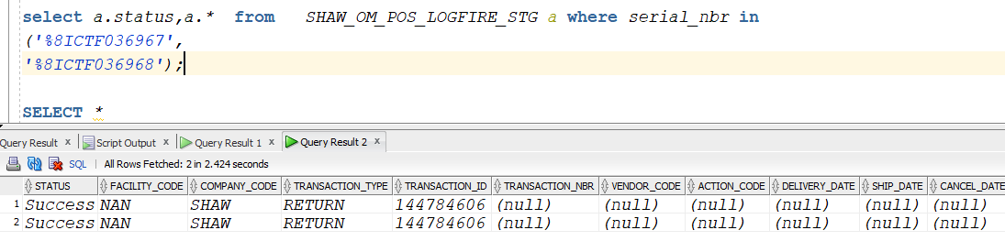

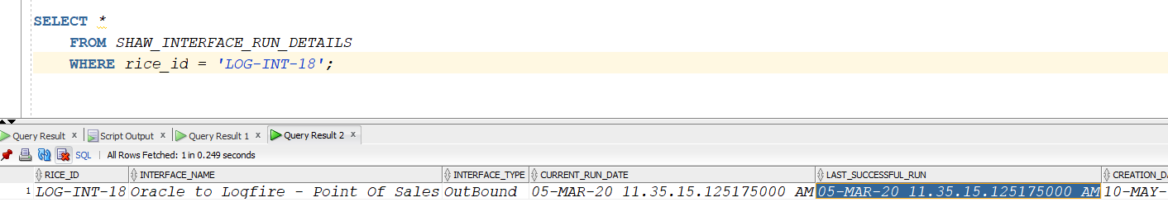

**TRACKING IN ICS**

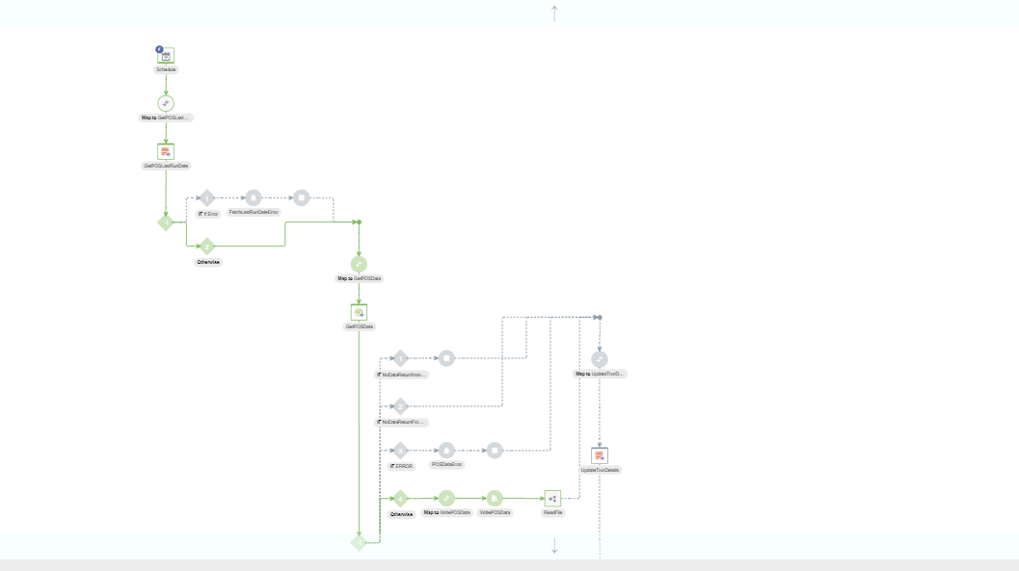

**3rd Scenario**

**ONLY REPROCESSED RECORDS**

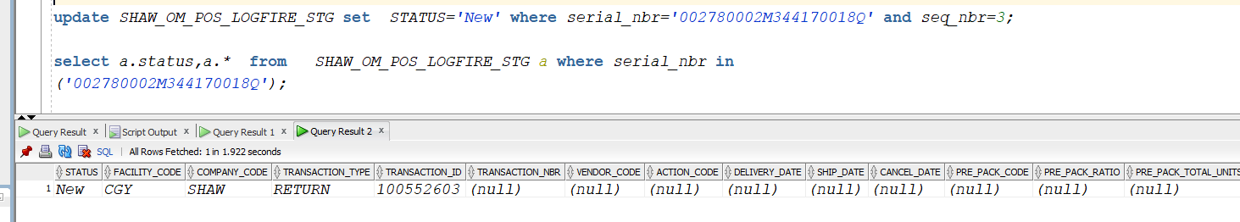

**NO DATA WHICH WILL BE FETCHED FROM ERP QUERY THROUGH WEB SERVICE IN ICS**

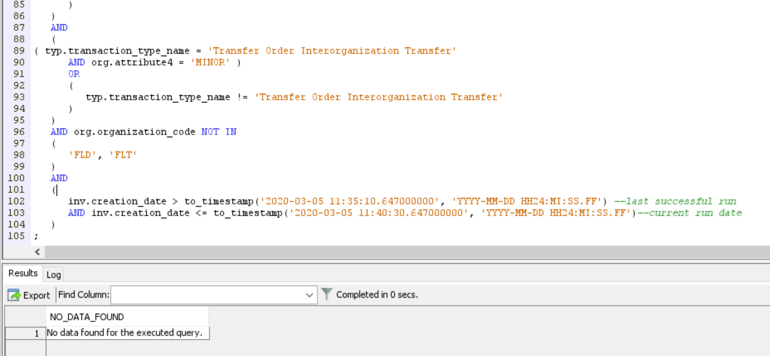

**SUBMIT INTEGRATION**

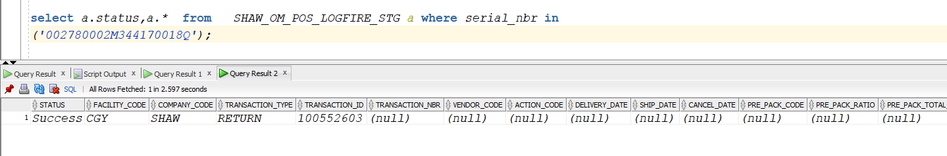

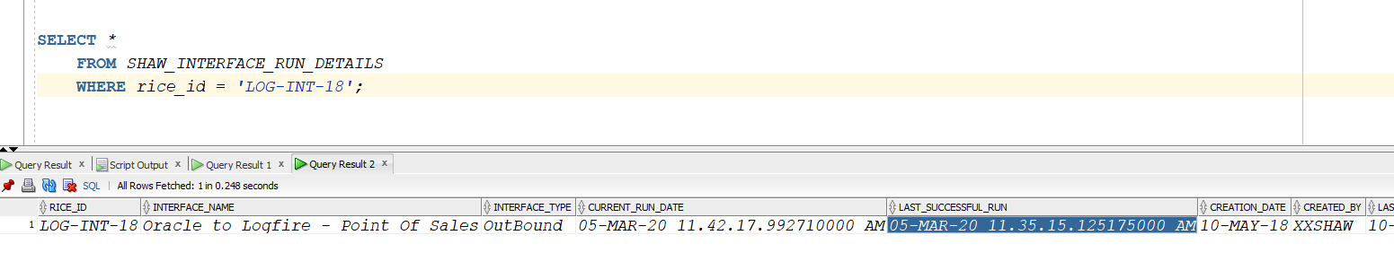

**LAST_SUCCESSFULL_RUN_DATE NOT UPDATED**

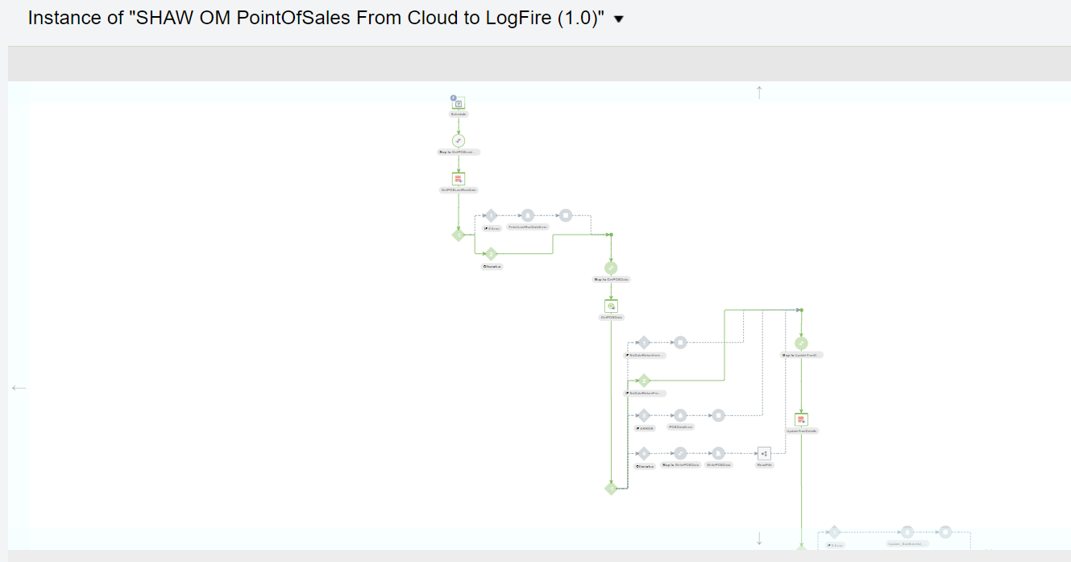

4) **ONLY NEW RECORDS**

**LAST_SUCCESSFUL_RUN**

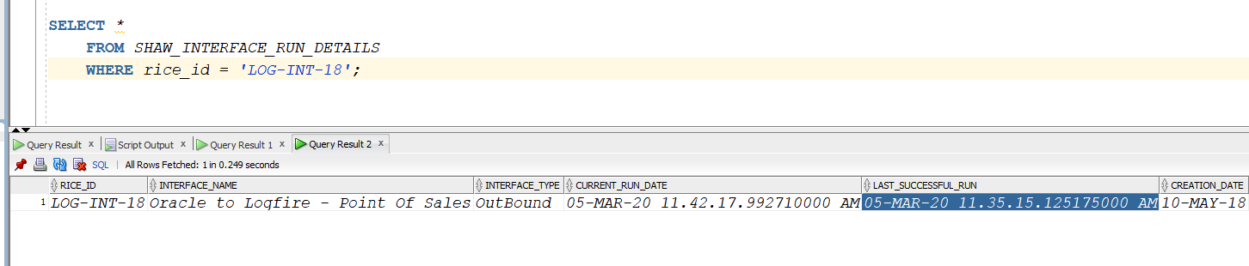

**CURRENT_RUN_DATE**

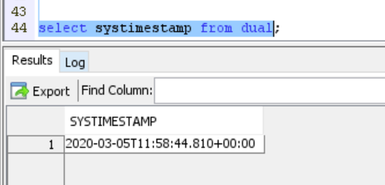

**DATA WHICH WILL BE FETCHED FROM ERP QUERY THROUGH WEB SERVICE IN ICS**

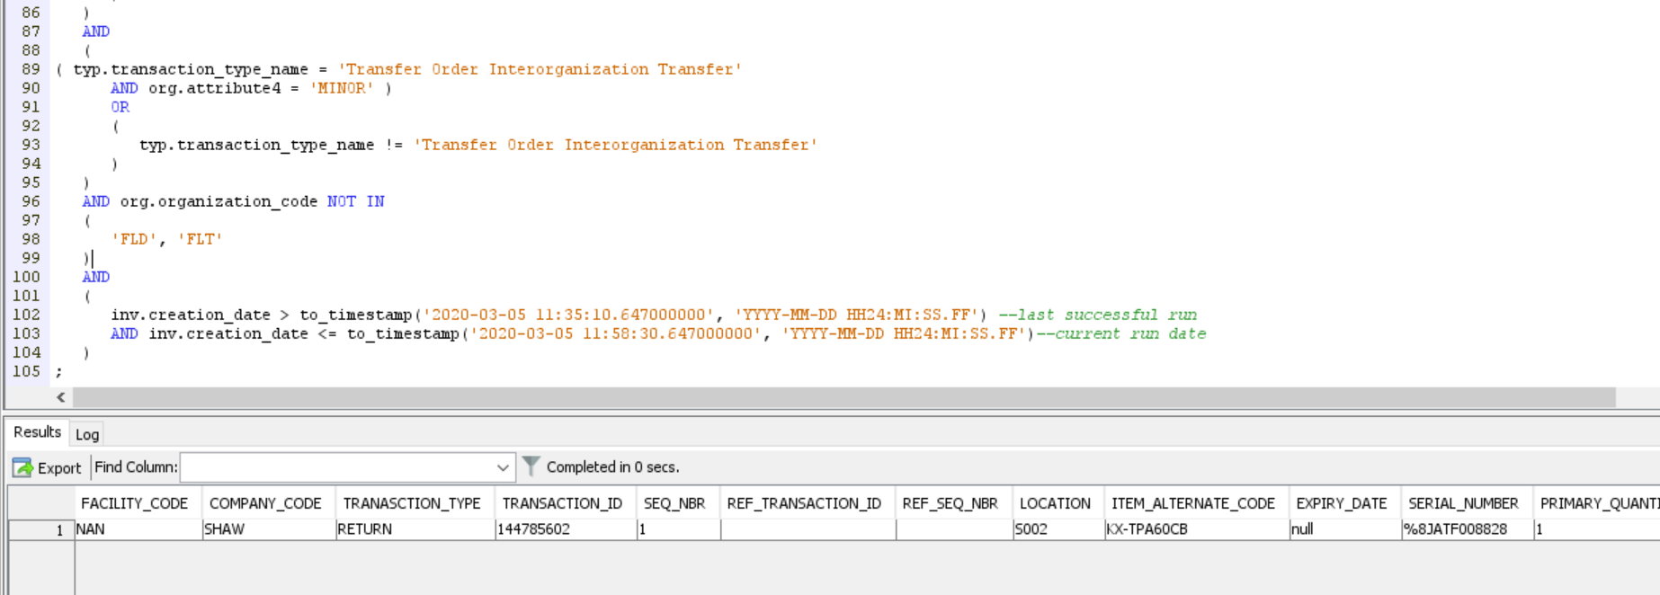

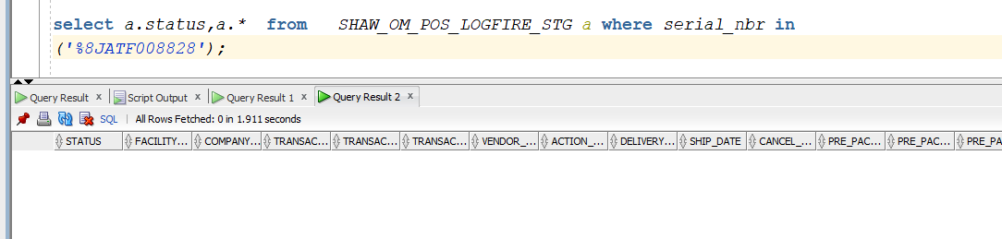

**SUBMIT INTEGRATION**

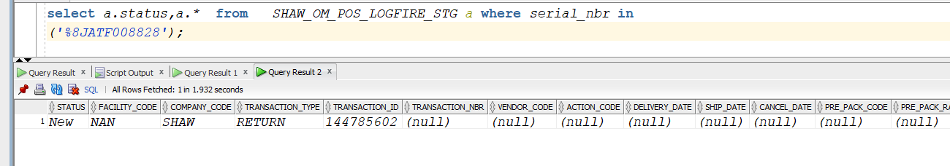

**RECORDS GOT PROCESSED**

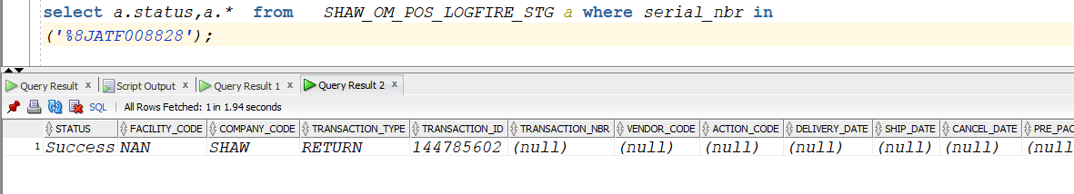

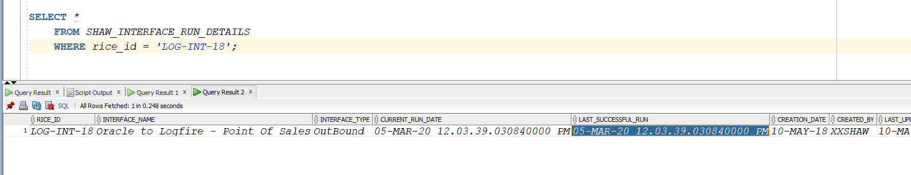

**TRACKING IN ICS**

